Blake Bortles Report

The Jacksonville Jaguars have been known as one of the more mediocre teams in the history of the NFL. They have never reached the coveted Super Bowl, being one of four teams for this to be the case. The closest they were to the Super Bowl was in the 2017 season, where they barely lost to the Patriots in the AFC Championship. The success of the Jaguars in 2017 was surprising; prior to this year, they haven’t had a season where they won more than 50% of their games outside of the playoffs since 2007. Their quarterback, Blake Bortles, was at the helm as its quarterback. Bortles was viewed as mediocre by many, but nonetheless led his team to the game before the Super Bowl. Despite the opinion of football fans, we found sufficient evidence that even if he was subpar most of his career, he had one of his best seasons in 2017 in terms of quarterback performance. In this report, we discuss how we evaluate his performance and show that compared to other years, 2017 is a vast improvement in Bortle’s execution.
To conduct our analysis of Bortles between seasons, we first need to find in-game statistics that measure quarterback performance. I found related statistics to be third down completions / attempts, pass yards, passing completions / attempts, amount of times sacked, and amount of times he has been intercepted. I format third completion / attempts and passing completions / attempts as a ratio for each respectively in the format of
$\frac{completions}{attempts}$
which will always be between 0 and 1. The higher the ratio, the better the quarterback performance. Pass yards, times sacked, and times intercepted are numerical values that won’t be altered, with the higher pass yards indicating better performance and higher times sacked and times intercepted indicating worse performance.
While these statistics are all related to the quarterback, it is also possible for other players to influence these statistics. For example, if Bortles threw a perfect pass to his wide receiver and they dropped the ball, it would be the fault of the receiver. However, the dataset available does not identify if something like this happened for a certain play, so 100% accuracy cannot be determined. Since this is a shortcoming within the data set we cannot fix, we will use the statistics as is and assess only Bortles’ performance. Another shortcoming within the data is that Bortles is what is called a dual-threat quarterback - not only does he pass to his receivers, but he is agile and will sometimes run with the ball himself. However, the dataset does not differentiate between rushing yards for the running back or the quarterback. Hence, we are choosing to omit analyzing rushing yards as a statistic of interest. Finally, for every statistic we have mentioned, we are going to be comparing the mean across all seasons. Due to Bortles playing less games in some seasons and more games in others, it is not justified to compare sums. Thus, every number seen will be a mean from a specific season in which Bortles played.
We first look at our ratios for third downs and passing. As we can see in table 1, Bortles does not look to play much better in 2017 compared to his other seasons. While these numbers are not bad, there is no drastic difference in 2017, indicating that he was playing at the same level in regards to completions and third down conversions than his other seasons.

Table 1. Bortles’ quarterback statistics by season
Season | Average Completion Percent | Average Percent of Third Down Conversions | Average Interceptions Per Game
2014 | 0.586447 | 0.32719 | 1.153846
2015 | 0.585524 | 0.340721 | 1.125
2016 | 0.584306 | 0.342374 | 1
2017 | 0.594 | 0.369743 | 0.684211
2018 | 0.610037 | 0.417091 | 0.923077
Note: Average Percent of Third Down Conversions can be interpreted as “in 2014, Bortles converted 32.7% of his third downs on average”. Similar interpretation for Average Completion Percent.

With his average completion percent being stagnant, one may think that he must have made throws that were much greater in distance more often to have made it that far in the playoffs. However, we see that this also is not the case. Looking at figure 1, we can see that his average pass yards for 2017 are truly middle of the road. 2015 and 2016 saw him pass much more on average, so we can only conclude that Bortles had a decline in performance in passing. Thus, in terms of passing and third down conversions, Bortles either played just as well or worse than other seasons.

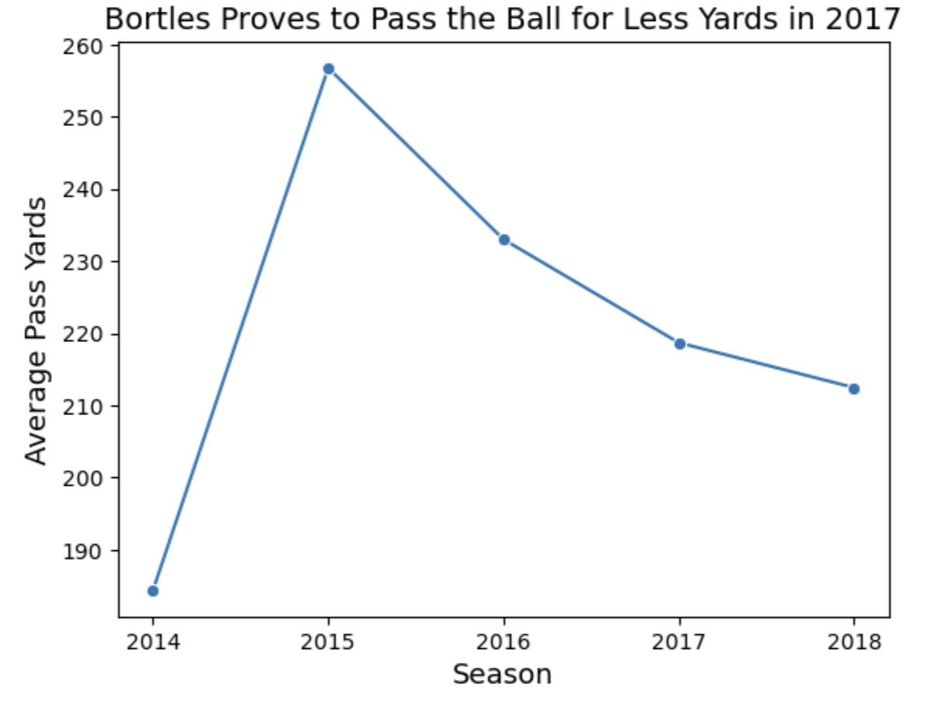
Figure 1. Graph of Bortles’ average pass yards

Bortles looks to bounce back with his average interceptions and thrown and average times sacked. Looking at table 1, we see his average interceptions thrown for 2017, is 0.684, marginally lower than his average interceptions thrown in any other season. As Bortles was a quarterback who was infamous for his turnovers when he played, this is a huge improvement and ought to help the team a ton in getting the win over other teams. This trend follows when looking at average times sacked per game; As we can see in figure 2, Bortles greatly improved in the 2017 season in terms of avoiding getting sacked. The less Bortles gets sacked, the more the Jaguars stay in the game, which is one of the reasons why they were able to get far into the playoffs that year. Thus, between interceptions thrown and amount of times sacked, Bortles seems to make a huge improvement that helps his team.
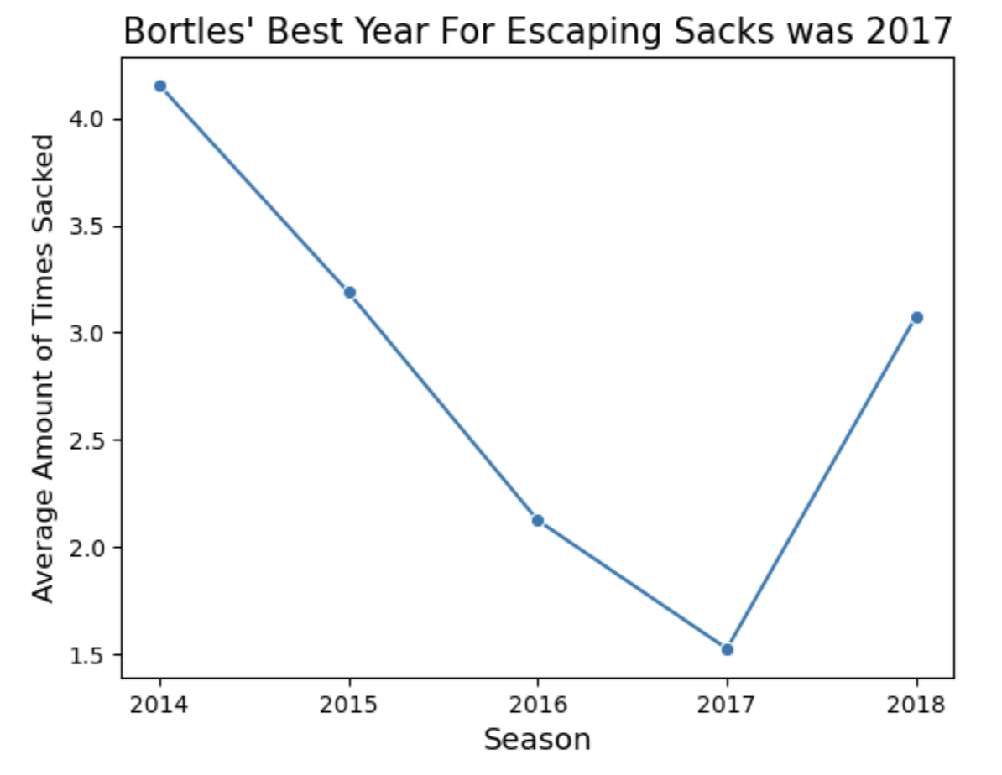
Figure 2. Graph of Bortles’ average times sacked
Ultimately, we see Bortles’ improve in some areas, or stay stagnant or slightly worsen in other areas. Thus, since Bortles does not regress, I believe that it is fair to say that 2017 is his best season. As shown by the statistics above, he proved to be a helpful asset that improved upon his previous seasons. While Bortles did end up getting worse in his final season with the Jaguars in 2018, I think it is fair to say that fans should not overlook his performance in 2017 and appreciate what he was able to bring to the team in the most successful season in Jaguar’s history.

